**Name :A. Aishwarya**

**192225114**

**EXP 1:Demonstrate virtualization by Installing Type -2 Hypervisor in your device, create and configure VM image with a Host Operating system (Either Windows/Linux)**

**Step 1:**

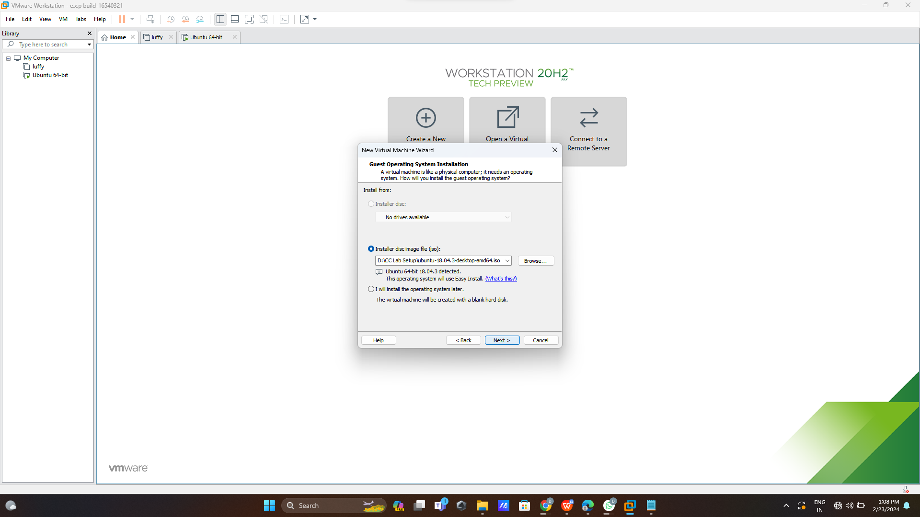

**Step 2:create id and password**

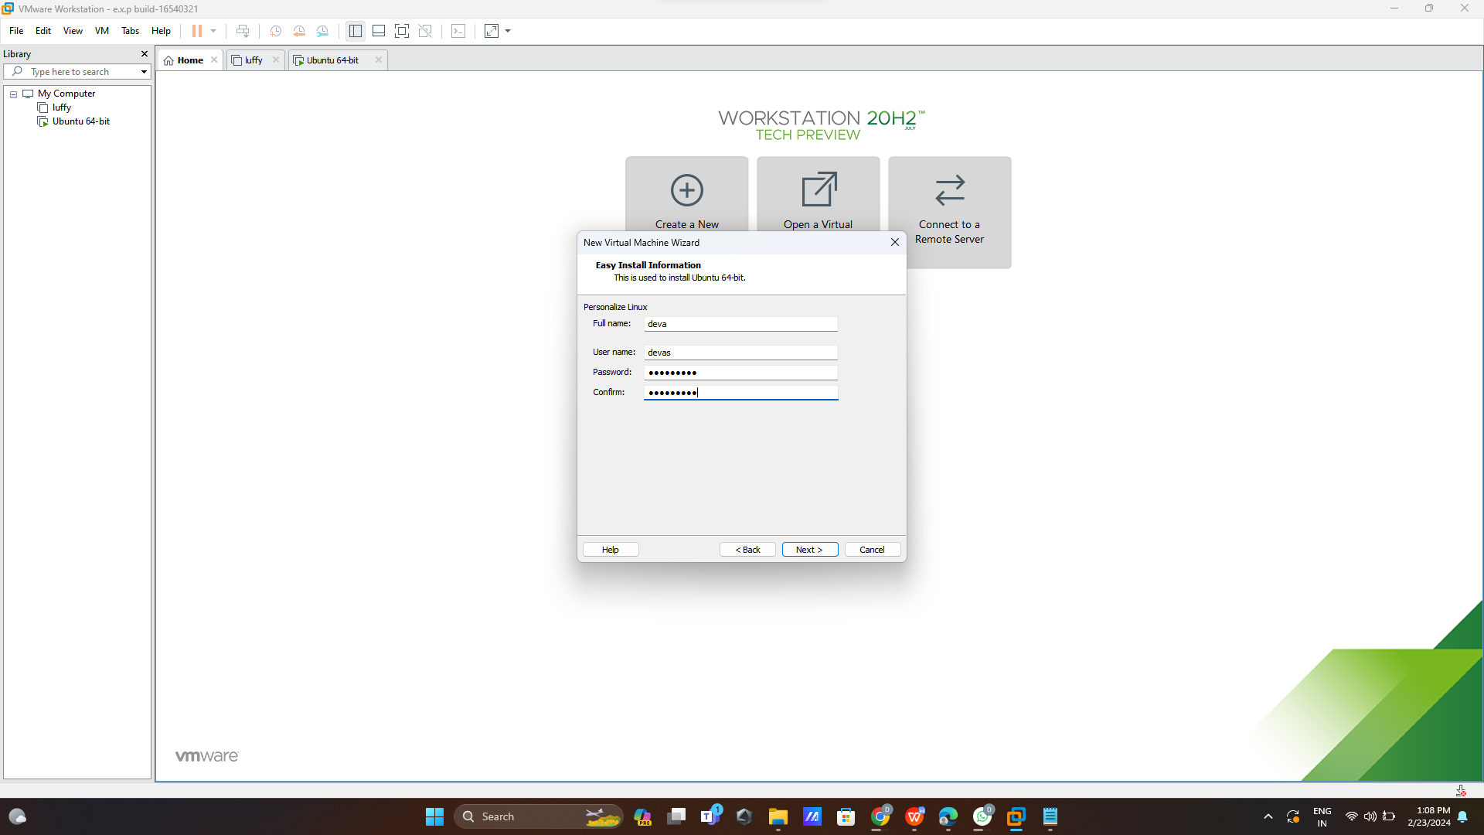

**Step 3:**

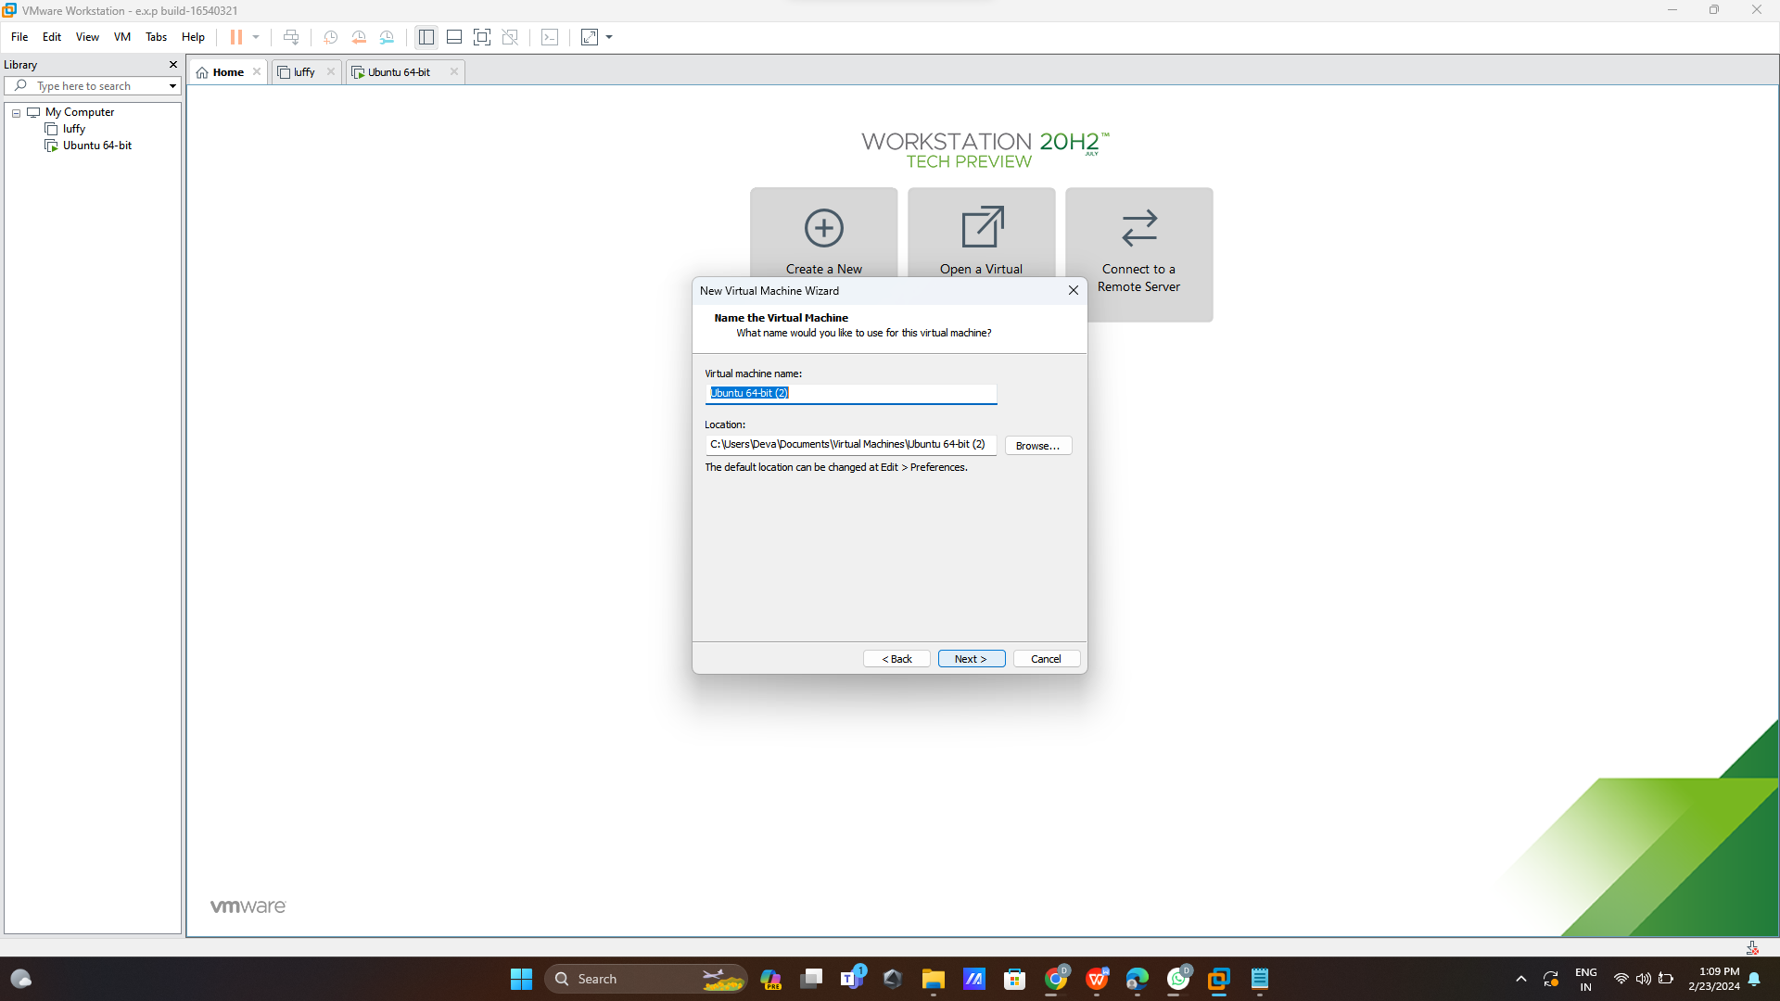

**Step 4:add size 30GB**

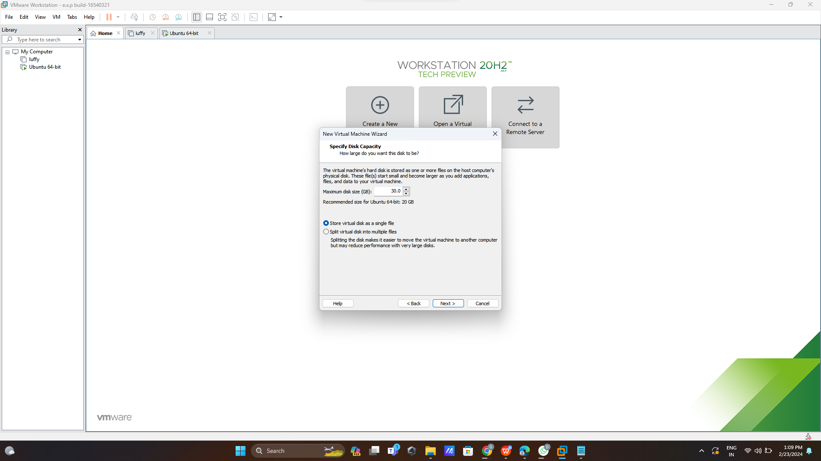

**Step 5:**

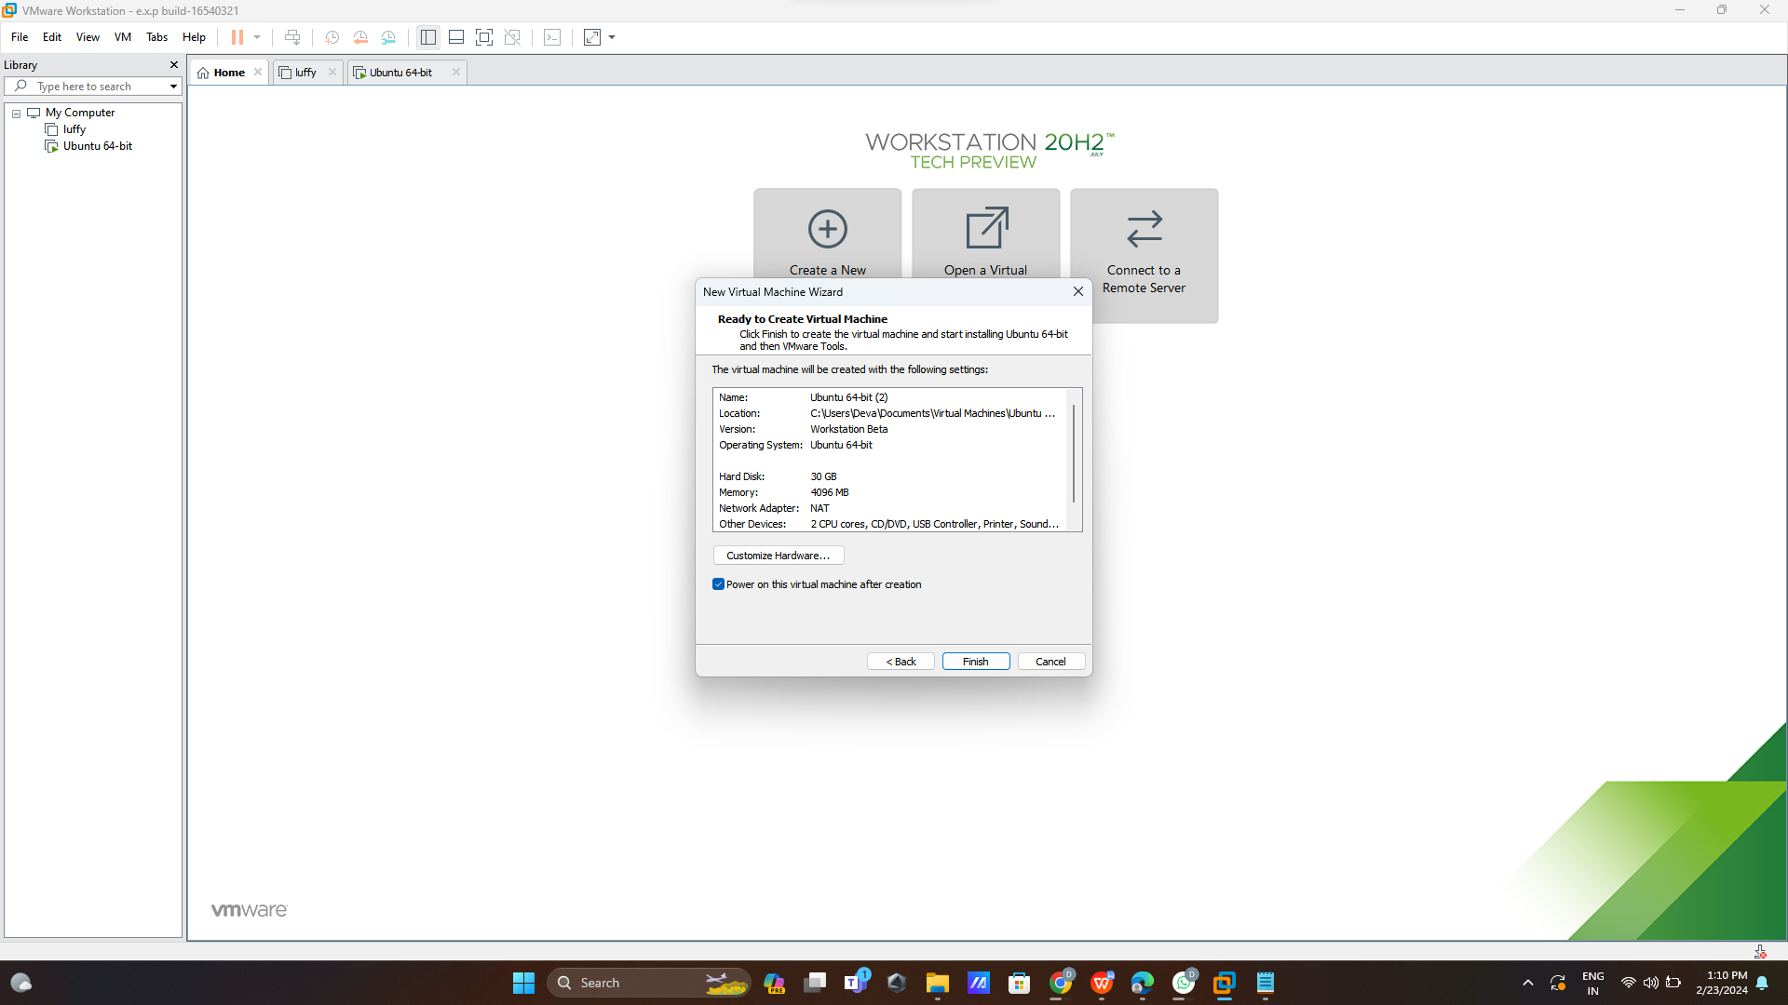

**Step 6:run**

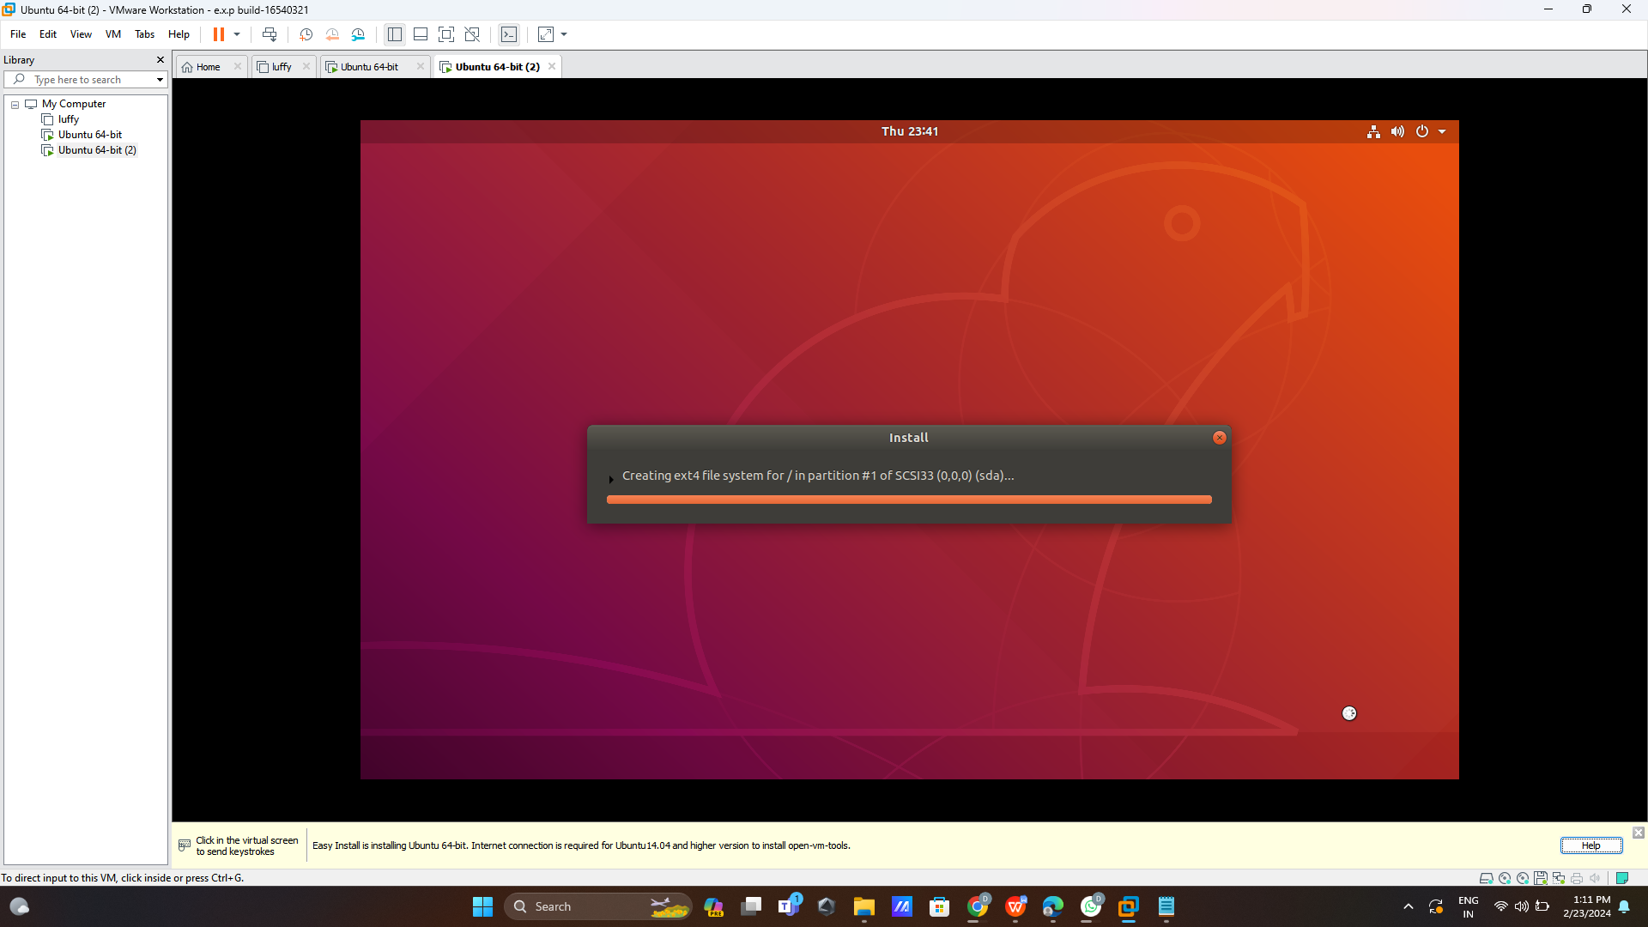

**Step 7:Login user id**

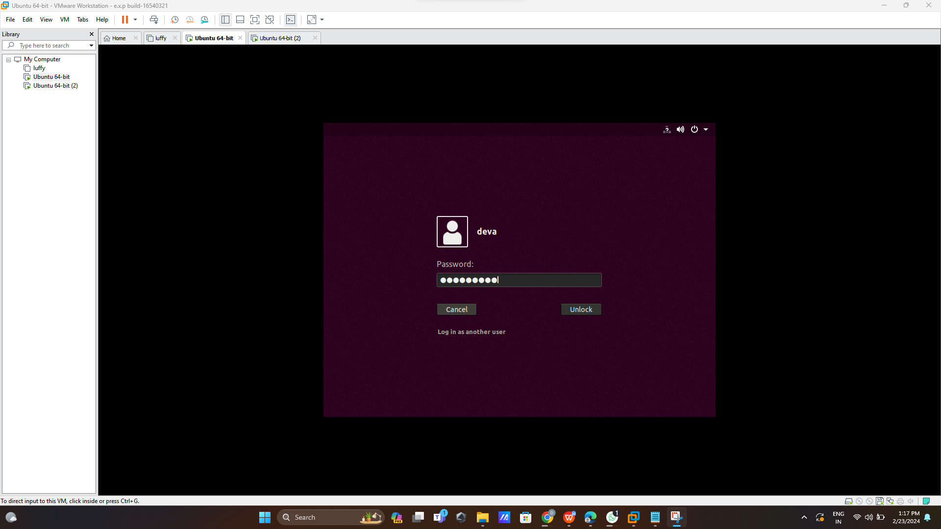

**Step 8:open user page**

